* for display foreign key value instead of id we should declare relations in model
* there are many types of relations in yii2 database

* here is example of how to show "country_name" instead of "country_id"

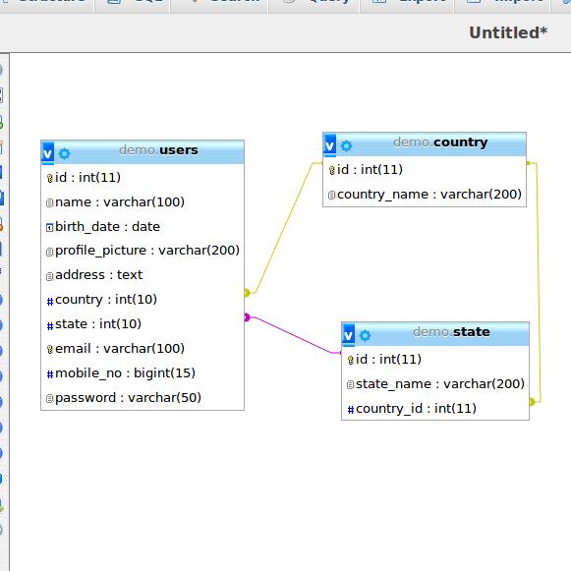

* here, in “country” table “id” is primary key and in table “users” field “country_id” is foreign key.
* now, in yii search table this shows us like this.

* for this, we write below code to “index.php” of search in GridView::widget

[
'attribute' => 'country',
'format' => 'text',
'value' => function($model)
{
$country = Country::find()->asArray()->where(['id' =>$model->country])->all();
return sizeof($country) ? $country[0]['country_name'] : '-';
} ,
],

* By this we can get value of “country_name” in search table

* Now, after all this still we can not search “country” by its name. So, for this
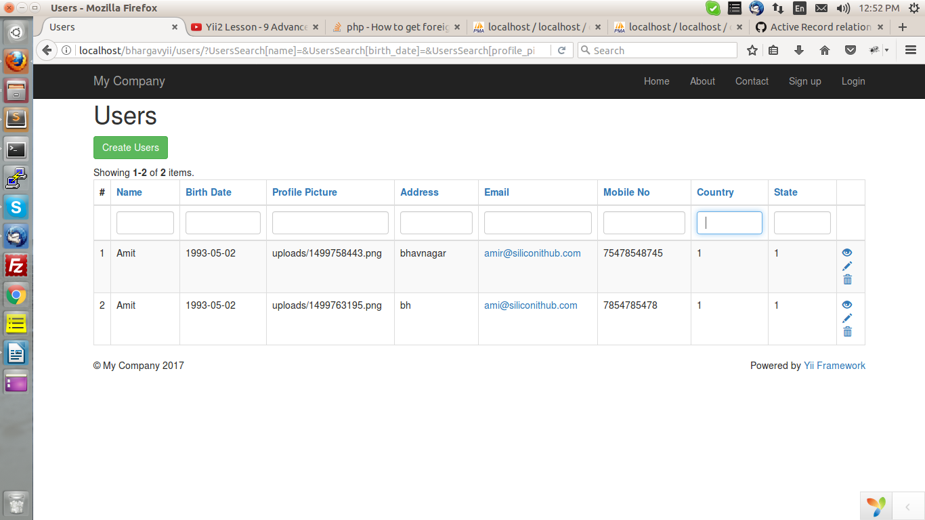

* we should declare relation in “Users.php” Modal,

public function relations()
{
return
[
'country'=>[self::BELONGS_TO, 'country', 'id'],
];
}

* and definde relations

public function getCountry()
{
return $this->hasOne(Country::className(), ['id' => 'country']);
}

* and “UsersSearch.php” write join syntax

$query->joinWith('country');

and write one condition like this,

->andFilterWhere(['like', 'country.country_name', $this->country]);

* by this we can also search country by name.

